There was no billboard that said
“WELCOME TO LAOS”

Steve Woods, Keith Shafer, Jerry Graff and Wayne “Doc Gordie” Gordon

Written by Phil Marshall

From the 366th Tactical Fighter Wing – Da Nang Gunfighter Gazette, Volume V, Number 8, dated December 5, 1970:

By Captain Mike Freel

Da Nang may not be everyone’s cup of tea, but two 366th Tactical Fighter Wing pilots, Capt. James R. Robinson and 1st Lt. Donald A. Boulet II of the 421st and 390th Tactical Fighter Squadrons, respectively, will positively tell you Da Nang is all right.

“It beats punching out of an F-4 and spending 4 hours on the ground in hostile territory,” said Captain Robinson, who along with his back-seater, Lieutenant Boulet, did just that last Wednesday.

“We punched out at about 1500 feet in a heavy cloud bank,” explained Lieutenant Boulet, “which actually was a plus factor because ‘Charlie’ could not get a fix on us.”

The two landed on a ridge about a mile apart in country that was described by Captain Robinson, “as rolling, muddy and full of trails, which you can be sure we both did our best to avoid.”

“The punch out and the landing was uneventful except I got hung up in a tree about six feet off the ground,” continued the captain.

The first SAR (Search and Rescue -Ed.) aircraft on the scene were the “Spads” and “Jolly Greens” from Da Nang followed by U.S. Army “Huey” helicopters.

“We can’t say enough for the rescue people who came to our aid,” praised Captain Robinson, “especially the ‘Huey’ from the 571st U.S. Army Medical Detachment from Quang Tri, piloted by Warrant Officer Woods.

“Those guys really ‘stuck it out’ flying back and forth across the terrain trying to get a fix on us. In fact they took sufficient battle damage on the first try to extract us that they had to recover and return with a second chopper to get us out,” added Lieutenant Boulet.

“Our sincere thanks to all who participated,” said both aviators.

“An exciting day,” said Captain Robinson, whose 29th birthday was, you guessed it, last Wednesday.

And so it went; that day in 1970, as two more lives were saved by a DUSTOFF crew in South Viet Nam. But as our “good friend and newscaster” Paul Harvey says, “And now you’ll hear, the rrrrest of the story…”

During this period of the Viet Nam War, things became so “busy” in Northern I Corps that assets of the 237th Medical Detachment, DMZ DUSTOFF, and the 571st Medical Detachment, Phu Bai DUSTOFF, were often combined to complete missions. Losses to both aircraft and personnel in those two units were so high that crews and aircraft were often “mixed together”. This included additional aircraft from other units, including the 498th Medical Detachment, but no other personnel from the 498th, only helicopters.

On this particular mission, Warrant Officer Steven Woods and 1LT Keith O. Shafer were assigned to the 571st while the other crew members on board were from the 237th. The aircraft on this mission was 69-15216, “The Peace Seeker”, as the nose art indicated, an aircraft assigned to the 237th and normally flown by Crew Chief Specialist 4 Jerry Graff and Medic Specialist 4 Wayne “Doc Gordie” Gordon. Crew Chiefs were assigned to perform the daily maintenance of their aircraft and routinely flew each mission on “his” helicopter; there is a certain amount of military wisdom in that theory. “You worked on it, you fly in it!”

Following is Aircraft Commander Steve Woods’ statement:
“At 1000 hrs. on 2 Dec. 1970, I was notified by Lt. Shafer that two Air Force pilots had been shot down about 30 miles southwest of Quang Tri. I assembled an all volunteer crew to go on the search. I was Aircraft Commander, Lt. Shafer volunteered to fly as pilot and Specialist Graff was the Crew Chief and Specialist Gordon was the medic. I instructed the crew to install the hoist and then we departed for the crash site. The weather wasn’t very good but it didn’t give us much of a problem. I decided to fly low level and instructed the crew to maintain an alert for enemy fire. We arrived in the general area where the crew was shot down and began our search. We drew concentrated enemy fire on several occasions but only got hit once.”

1LT Keith O. Shafer:
“While we were on standby at Quang Tri, I got a call from ‘Pamper’, the radar guys. I was told that a Fox Four (F-4 Air Force jet) had gone down somewhere along the border and I believe they gave me some general coordinates but they did not have a pinpoint site. We did not realize at the time that we would wind up in Laos.”

“We had a solid low ceiling somewhere around 500-700 feet but the visibility was OK. As we headed out in the general area, we made contact with ‘King’, the Air Force Search and Rescue (SAR) Command and Control (C&C) aircraft. ‘King” was receiving a beeper signal from one of the downed pilots and tried to give us directions of where to head for our search. The area was about 35-40 minutes from Quang Tri so we only had about an hour of flight time on site before we would need to head back to refuel. At that time, we were the only ones below the clouds while all of the Air Force was above the cloud layer.”

Steve Woods continues:
“We remained on station until we got low on fuel and then returned to Mai Loc. We inspected the aircraft and found only minor damage. We went back to the area and continued the search. A Cobra spotted the parachute of the downed co-pilot. My Crew Chief spotted him on the ground. The medic operated the hoist and lifted him aboard while WO George advised me of my position. We located the pilot about 100 meters to the east and hoisted him aboard also. The performance of the entire crew was outstanding and made the rescue successful. Their determination in the face of enemy fire is indeed a tribute to Army Aviation.”

Keith Shafer continues:
“After refueling, we made contact with ‘King’ again and after much back and forth comm (communications) on guard we heard one of the Jolly Green Giant pilots say ‘If they could get the Army out of the way they would get the job done!’ Needless to say, this just pissed us off and made us more determined to find the downed pilots. By this time a Cobra gunship joined us on station so here we are- two Army helicopters searching the jungle low-level and half the Air Force is above the clouds doing their circle-jerk!”

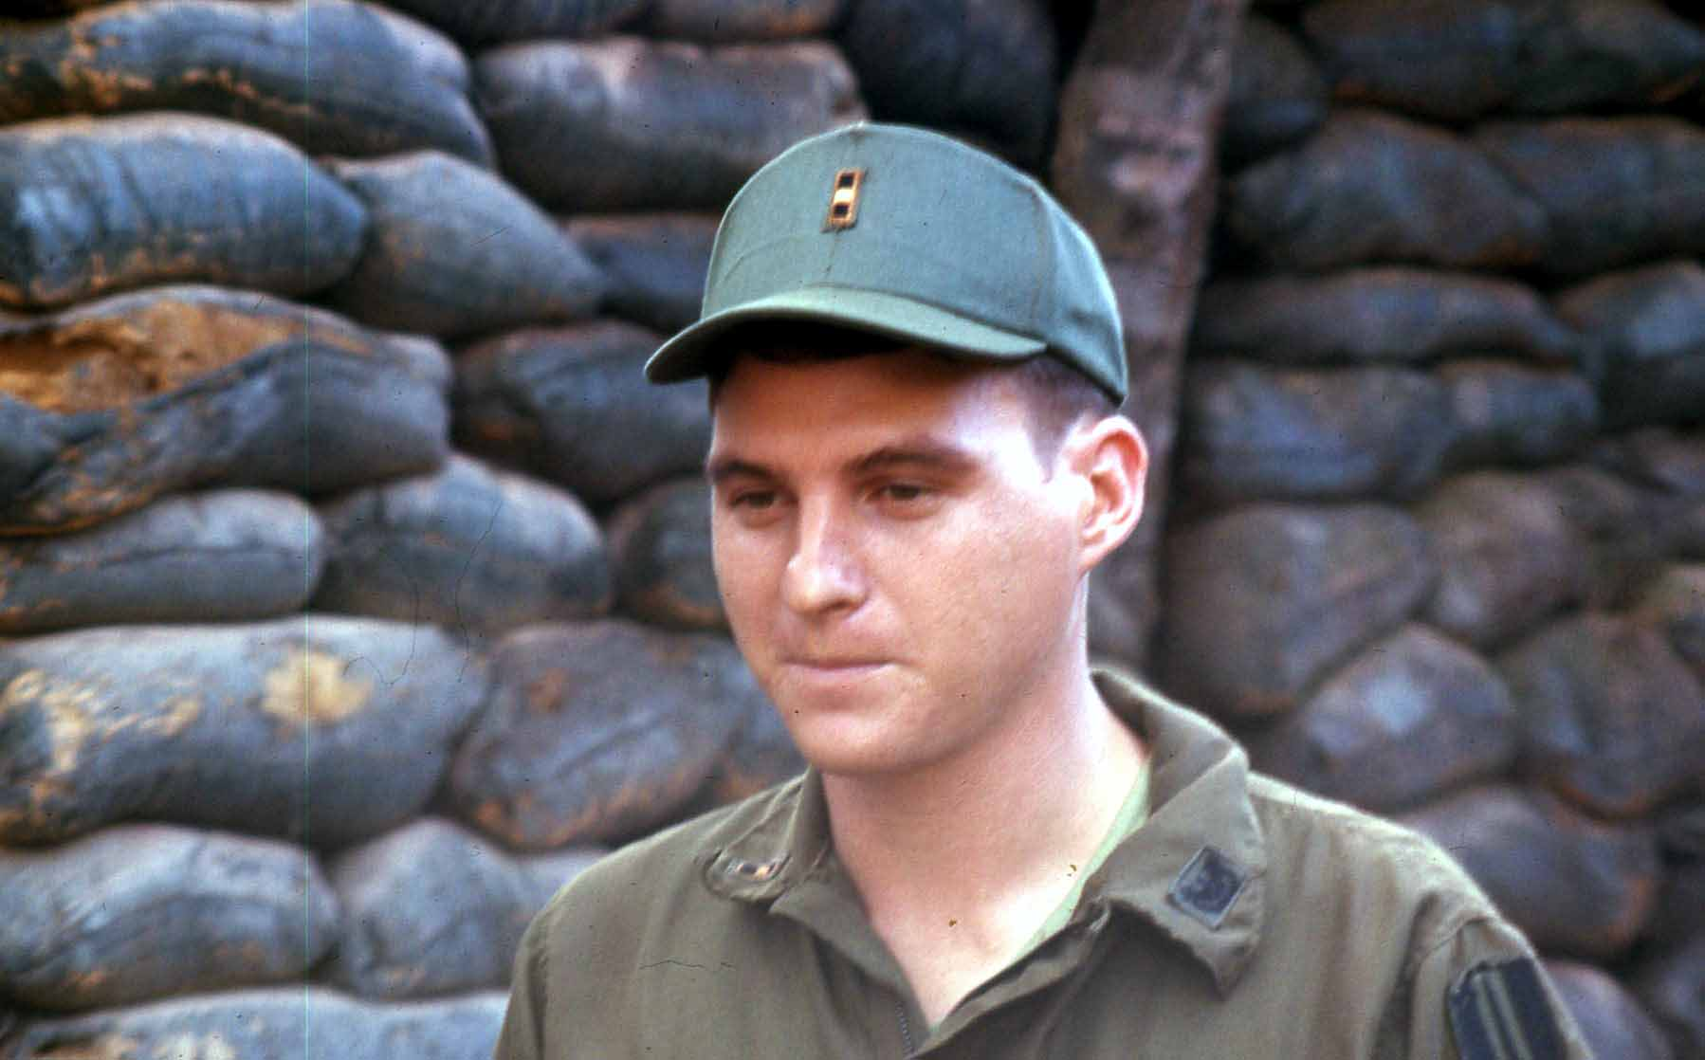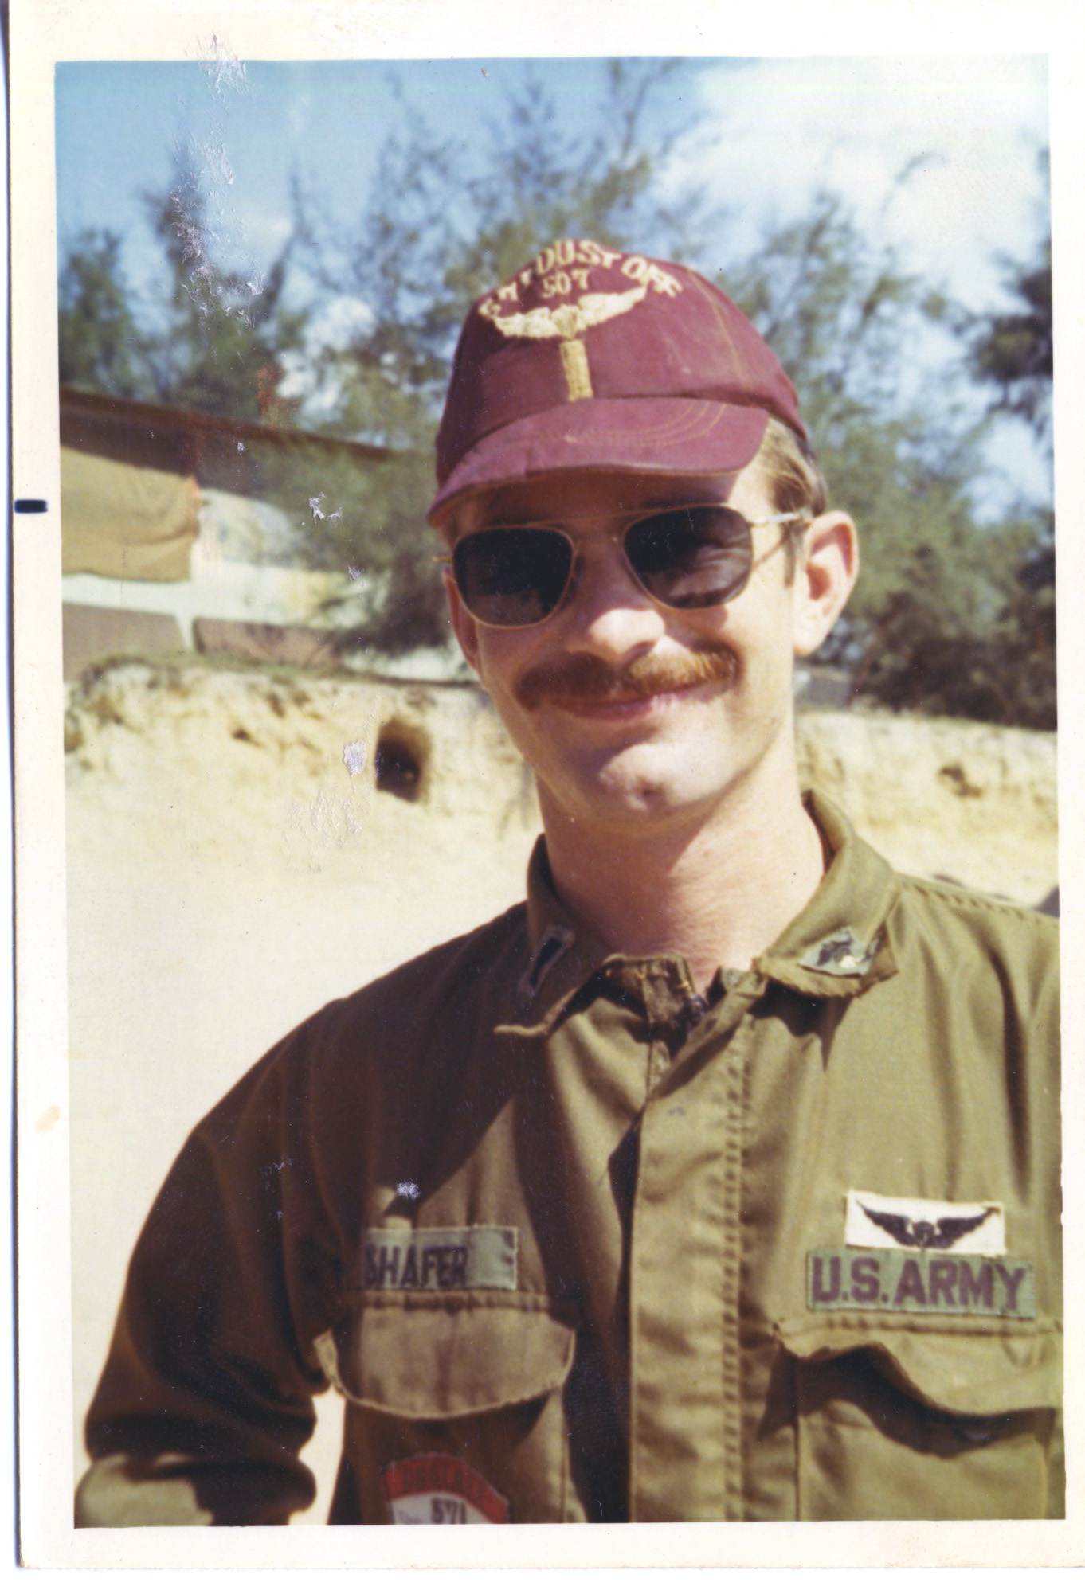

WO Steve Woods, Dustoff 509 LT Keith Shafer, Dustoff 507

Warrant Officer Kenneth George was in a second aircraft, supporting Mr. Woods. Mr. George’s statement:

“On 2 Dec 1970 I was pilot aboard Dustoff 710. Dustoff 509 received a request to perform a search and rescue mission for two pilots who had been shot down. Dustoff 710 flew out to Khe Sanh so that we could maintain communications with our sister ship and Dustoff Control. The area of the search was reported to be filled with enemy 37mm gun positions. Dustoff 509 drew concentrated enemy fire on several occasions but was able to make the rescue of the two pilots after 4 hours of search.”

(Note: Pilot call signs of the 571st stared with “5” and pilot call signs of the 237th started with a “7”. Thus, 509, 710, etc. As a 571st pilot, Mr. Woods was 509 and as a 237th pilot, Mr. George was 710.)

And the Cobra gunship? From Captain Joseph F. Keller; we can’t overlook his statement:

On 2 December 1970, I was the escort gunship team leader helping Dustoff 509 to extract two Air Force pilots who had been shot down about 30 miles southwest of Quang Tri. In making the pickup of the two pilots, Dustoff 509 was forced to contour fly low level in order to reduce exposure time. The area of the pickup site was in the location of a known enemy infiltration route. On several occasions, Dustoff 509 came under intense automatic weapons fire. Although he took hits in the tail boom of his aircraft, Dustoff 509 continued the mission. Disregarding their own safety, Dustoff 509 continued to search for the downed pilots. After much searching, Dustoff 509 was able to locate and hoist both of the pilots out. Only the skill of the two pilots and the bravery of the crew made the mission a complete success.

Keith Shafer:
I seem to remember the Cobra spotting the first chute and directing us over it. We hovered around for a little while still looking for the pilot while the Cobra Gunship dared anyone to fire at us. We knew he would watch our backs and blow the hell out of anyone who fired at us. The pilot finally crawled out from a bush and we hoisted him aboard.

After hoisting the second pilot aboard, 1LT Shafer continues:
We low-leveled our way back to Quang Tri and dropped off the pilots at the Emergency Room of the 18th Surgical Hospital. After shutting down, we inspected the aircraft and found several small arms hits in the tail boom. We then went in and talked to the pilots of ‘Stormy 02’. One had a sprained ankle but other than that they were both OK. They said they really got scared when we were flying tree top level heading back to the hospital!”

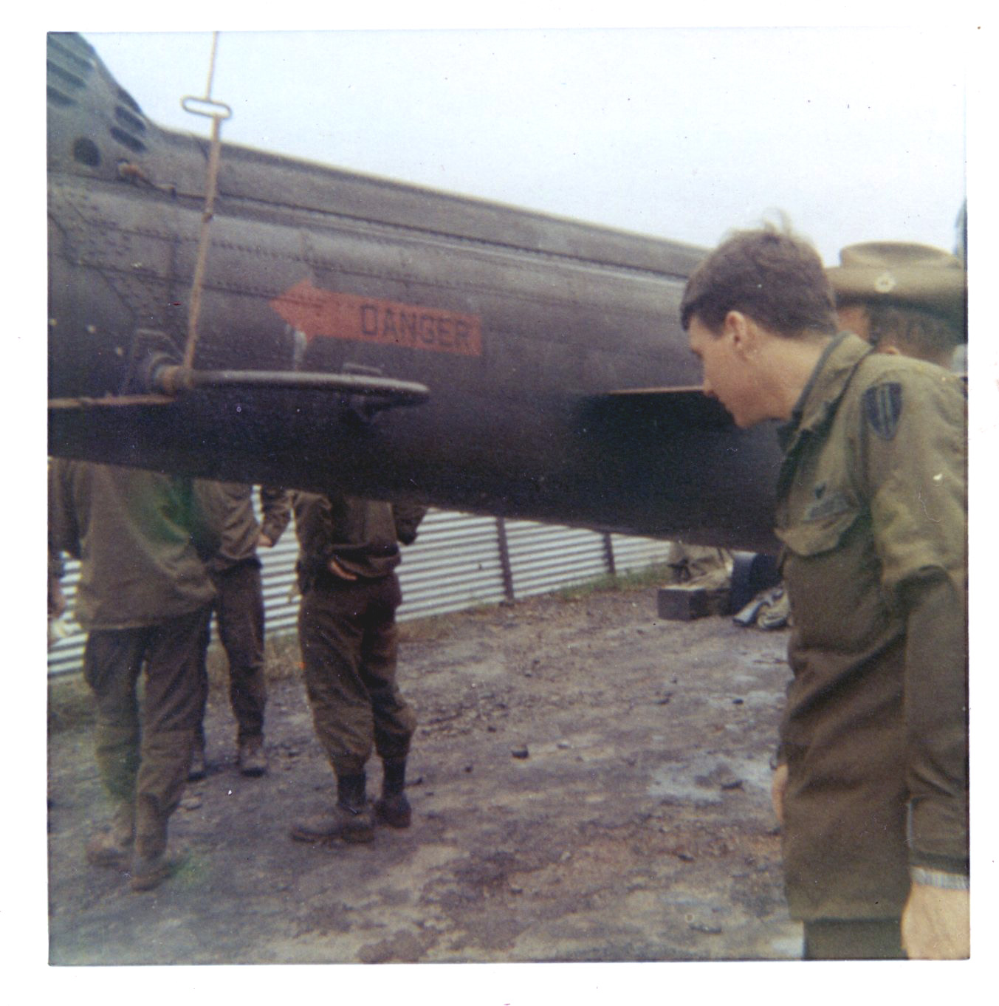
Aircraft Commander Woods inspecting the tail boom of 216 upon return to Quang Tri.

In a 1990 letter to Wayne Gordon, Jim Robinson offers more information about how they got shot down and a little bit of background on their mission. Portions of his letter include:

“There were 3 Air Force squadrons at Da Nang, 390th, 421st, 4th, but also a volunteer squadron by the name of ‘STORMY’ which took people (only volunteers) from the other 3 squadrons for a 3 month tour. The reason it was voluntary and only 3 months was that generally you got your ass shot off. We were a single ship operation doing high speed low level visual recon for targets of opportunity in North Vietnam, Laos and later, Cambodia. We carried no bombs, just a small pod of ‘willy pete’ (White Phosphorus –Ed.) rockets to mark targets and the 20mm cannon because we also had a backup S.A.R. mission. Don (my GIB from the 390^{th,} I was from the 421st) and I were in ‘STORMY’ the day you found us wandering around rural Laos lookin’ for a motel and a cold beer. We were just breezin’ down the ‘Laos Freeway’ at about 500 feet and 500 knots when it seems as though we pissed-off some North Vietnam tourist around ‘Delta-45’. You know some people just can’t take a joke…a little buzz
job and they really get irate!!! Well from that point forward my life turned to shit in a hand basket, but quick! Now, I’ve been hit before…but, hell, you don’t have to blow the whole airplane away to get my attention…I know when I’m not invited! EXIT – one F-4E Phantom Fighter (brand-spankin’ new…less than 400 hours…that pissed the Wing Commander off)…ENTER – one US Army (Who invited these guys!!!) Huey ‘Dustoff’ chopper!! The Air Force is still scratchin’ their head how you got involved…but to Don and I it could have been the Lone Ranger, Batman and his queer sidekick Robin or Three Fiddlers Fiddling…you looked like the ‘Great White Knight’ to us with two tickets out of Laos-land and totally incorrigible company!! Cleanin’ up their rice-paddies (at the very best…not likely) or being face down in a pool of my own blood (more likely than not) was not my idea of “career advancement”!!! Needless to say…thanks once again.”

Wayne Gordon replied to Captain Robinson’s letter; here is an excerpt from it:

“While we were getting the coordinates and checking all of our equipment….They gave us encouragement by saying we’ll give you all the protection you need…just get our men out! Our ship crossed the border into Laos and proceeded to your approximate position…which looked like a Kennedy Airport air show….There were so many different kinds of aircraft looking for you guys…we went into a valley at treetop level, went up the crest of a hill when the jungle below us opened up….Mr. Woods did a 180 and went top end speed trimming trees to get out of range, we thought we saw something below….Being low on fuel, we left and went back to Viet Nam to refuel and assess the damage at Mai Loc…Jerry said it was not structural…took a vote if we should go back…we all said ‘Let’s go’….Off we went to get you guys out…A lot of things were in your favor….you had the best Pilots in our Units,….Jerry knew what the ship was able to withstand….and having a medic who did HOT HOIST before….Not to mention that we usually don’t carry the Hoist on board unless requested…So with all these in order and a little luck we should be able to get you out!.....and thank God it worked…!

After our flight back to Quang Tri, 18th Surgical Hospital, an Army Officer balled us out for violating another country’s airspace…your commander praised us and said we were going to get a medal for our action…The Army Officer told us not to accept it, that the Army was going to give it to us….Isn’t that a kick in the ass…here we are saving two American asses and we got balled out…that’s the Army for ya!”

Crew Chief Jerry Graff remembers this mission:

“This is one of the only missions I remember almost step by step in my mind and it might be because that is the day I destroyed my back or because I had the two aircraft to set up as we switched crews and equipment, I don't know for sure. I remember small details about that day that would turn this story into a book in itself.”

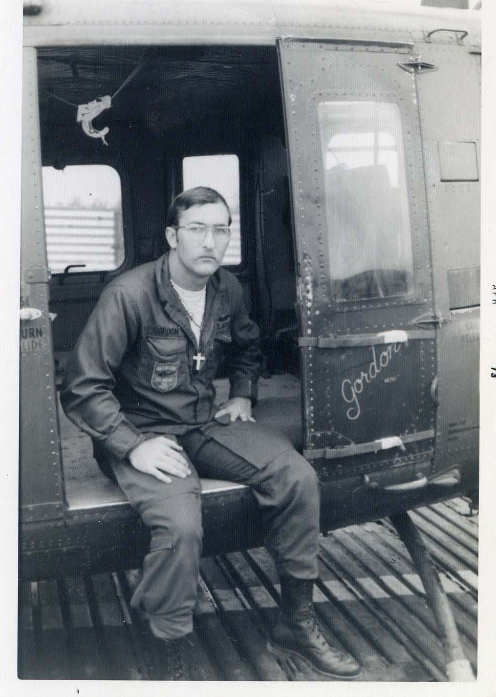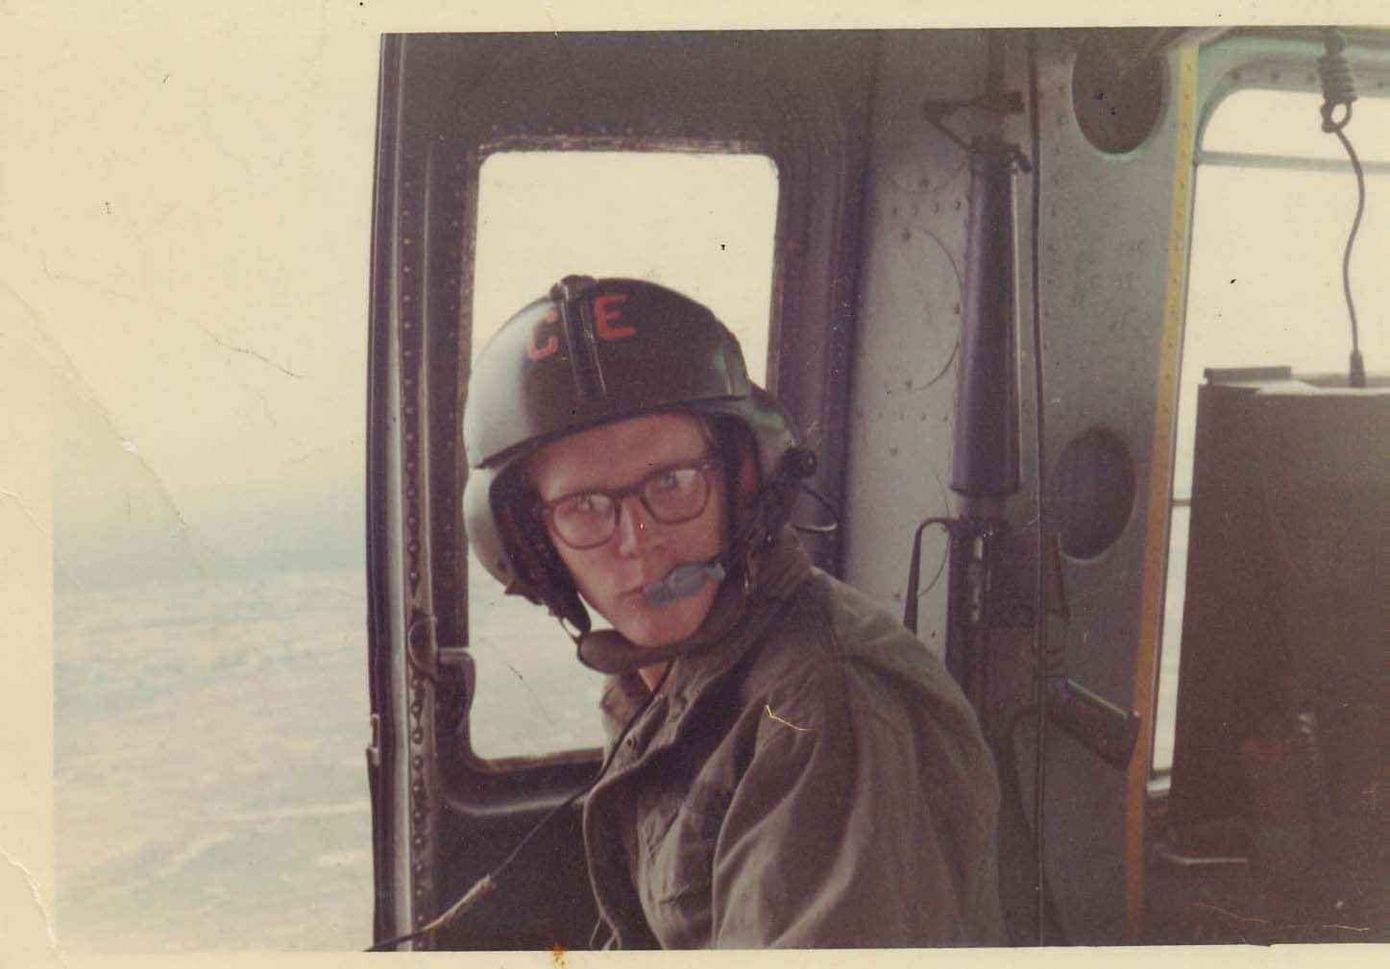

“Doc” Wayne Gordon, Medic Jerry Graff, Crew Chief

Soon after the rescue, a party was thrown in Da Nang by the Air Force’s 366th Tactical Fighter Wing for the crew of Dustoff 509. Doc Gordie continues his letter to Robinson with this recollection:

“The party was hard to forget….you guys had a Hall filled with food that us Army Fly Boys don’t see!...roast beef, turkey, potatoes, jello, salads and only God knows what else…the Champaign we had to chug-a-lug (which I haven’t touched since that time)…the wheel barrow with the gold balls that were hung on our zippers by a Lady in a flight suit…saying we had BRASS BALLS…your Commanding Officer stood up on stage….rose his arms into the air over his head…you guys stood at attention with your glasses toasting him and saying…. ‘HIM…HIM…FUCK HIM’…then proceeded to throw food and junk at him until he lowered his arms…then you all sat down with respect!...It was unbelievable…Air Force pilots are too much…I don’t remember much about that day except HUGGING your FLUSHED TOILET and meeting RRRRRRRAALPH!!, AND YOUR FALCONS…..and the most interestin’ flight back to Phu Bai in our DRUNKIN’ HAZE…I still don’t know how we got back, we wobbled and rocked back and forth in the air and had one of our roughest landings ever!!!!...but worth every minute of it.

Keith Shafer remembers a little more detail:

“That was the best party I have ever been to. I remember our whole crew going through a receiving line of all the fighter wing pilots to include the Jolly Green pilots. When Woody asked which one said he wanted us to get out of the way so they could get the job done, the guilty party was identified. He offered us a ride in his ‘real helicopter’ and Woody told him ‘If you ain’t Dustoff, you ain’t shit- come ride with us and we will show you what it’s like to be a real pilot!’ I remember the Wing Commander saying ‘You give ‘em Hell, Woody!’ and slapped him on the back.”

“Yes, we did get some medals but I think all of us were rewarded with the idea of saving two guys from capture and have had the pleasure of being proud of that for the rest of our lives.”

So there it is, one mission in the tapestry of Dustoff in Viet Nam. Note that most everyone says “about 30 miles southwest of Quang Tri”…never “into Laos”. Why is that important? While the Air Force celebrated the Dustoff crew’s rescue of the two F-4 pilots with a “Major League” party, the Army wanted to Court Martial them for flying into Laos! It was OK for the bad guys to violate Laos, but not us! What’s up with that?
Doc Gordie’s statement during the interview for this story, I think, says it best. “We were flying off our maps and there was no billboard that said ‘Welcome to Laos!’”

The crew members of Dustoff 509 were all put in for the DFC, Distinguished Flying Cross, one of the highest awards a Dustoff crew member could hope to achieve. However, as it seems with most Dustoff award recommendations, they were downgraded. Instead of DFC’s, they were all awarded Air Medals with “V” device for Valor, still a prestigious recognition of their actions. Considering they were almost given a Court Martial for this mission, one would suppose they should be damned happy they didn’t lose their wings!

“And now you know, the rrrrest of the story!”

